**CHANGES 1:**

**Kindly change the colour of the number and remove 0. It should be +971 522381623 / 624 / 625**



**CHANGES 2:**

**Use Caps as mentioned – Make an Appointment (change everywhere)**

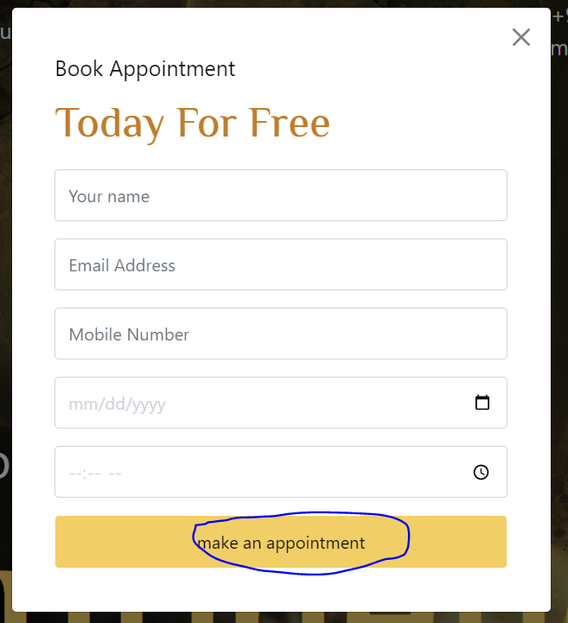

**CHANGES 3:**

**Make the content as center aligned**

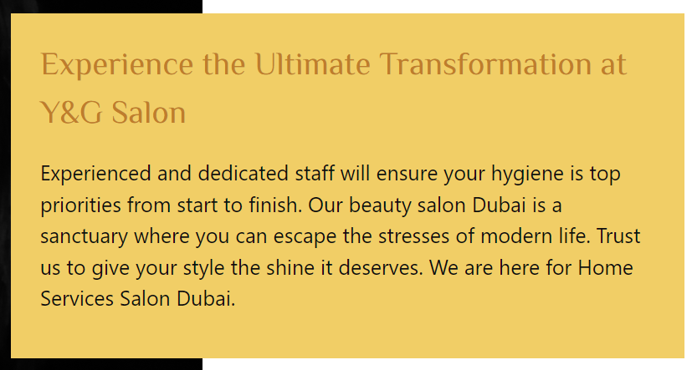

**CHANGES 4:**

**Make it in 1 line**

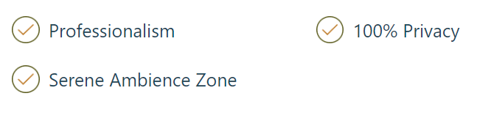

**CHANGES 5:**

**Remove the space**

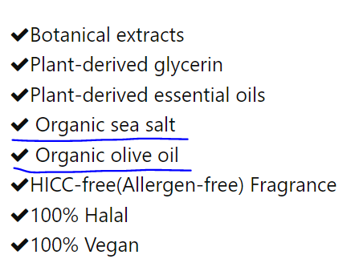

**CHANGES 6:**

**Make it same as UI**

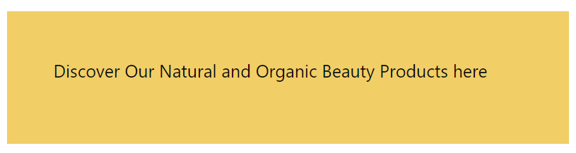

**CHANGES 7:**

**Make the line more visible**

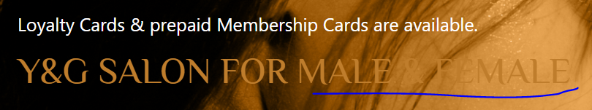

**CHANGES 8:**

**Make the spelling as – Services**

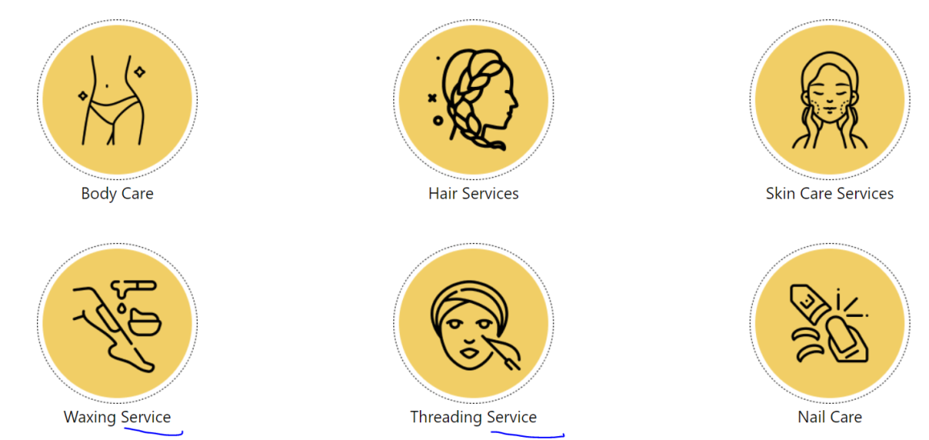

**CHANGES 9:**

**Add auto slider**

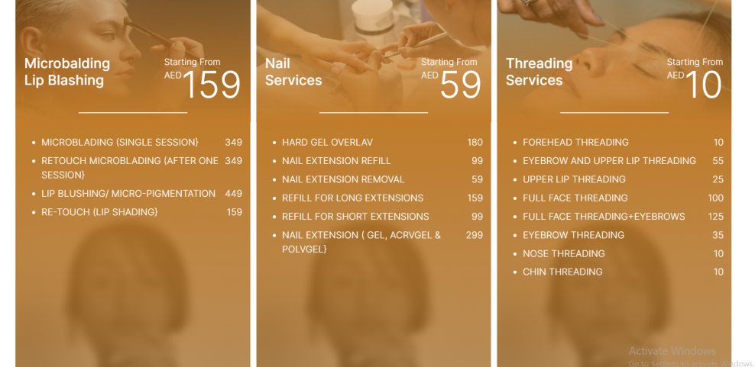

**CHANGES 10:**

**Add full stop here.**

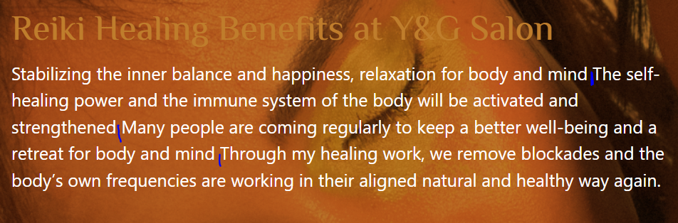

**CHANGES 11:**

**Make it caps – About Us**

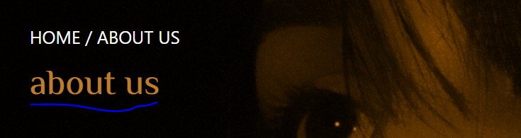

**CHANGES 12:**

**Change the font and make it Caps - WELCOME**

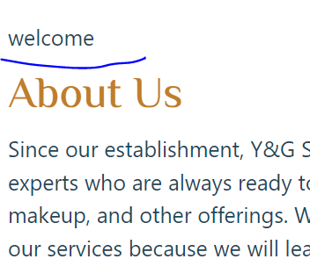

**CHANGES 13:**

**Make it center aligned.**

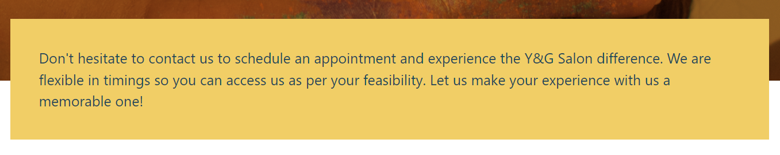

**CHANGES 14:**

**Remove the dot.**

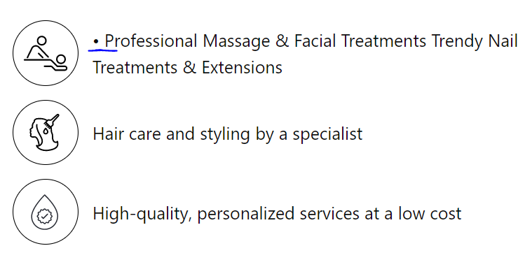

**CHANGES 15:**

**Change the email as –** [**info@ygsalon.ae**](mailto:info@ygsalon.ae) **(change everywhere)**

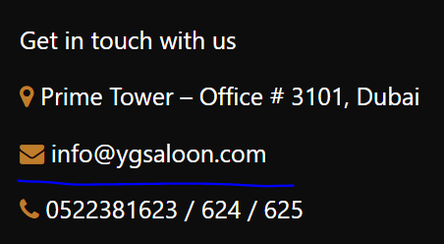

**CHANGES 16:**

**Make it caps – Our**

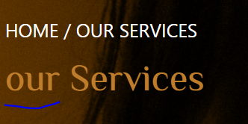

**CHANGES 17:**

**Make as Services**

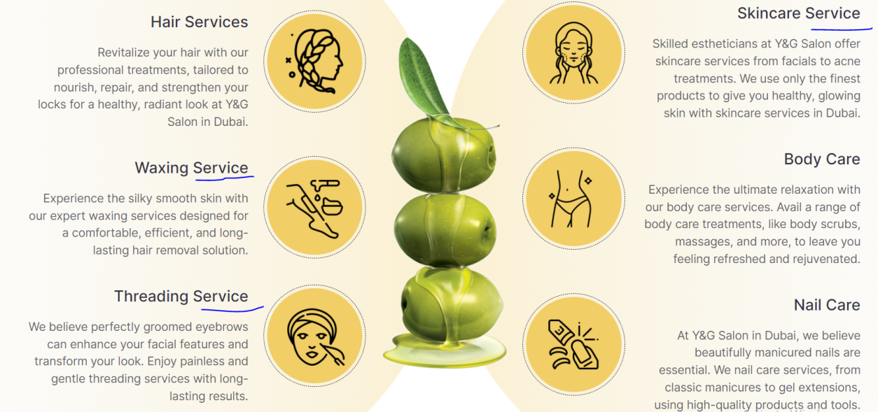

**CHANGES 18:**

**Make it caps - We**



**CHANGES 19:**

**Remove the line**

